10.64: For a tension T in the string, 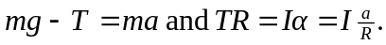 Eliminating T and solving for a gives
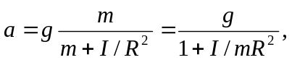

where m is the mass of the hanging weight, I is the moment of inertia of the disk combination and R is the radius of the disk to which the string is attached.
a) With m = 1.50 kg, 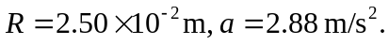
b) With m = 1.50 kg, 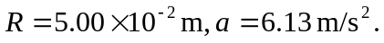
The acceleration is larger in case (b); with the string attached to the larger disk, the tension in the string is capable of applying a larger torque.

